NU–IACUC POLICY

Northeastern University Institutional Animal Care and Use Committee

Retro-Orbital Injection in Mice

IACUC Approval Date: 12/14/2021

Introduction:
The retro-orbital (RO) injection is an acceptable alternative to the intravenous (IV) tail vein injection procedure for injecting substances that must be injected intravenously. The route described in the protocol should be based on the researcher’s level of training and proficiency with the retro-orbital or tail vein injection. Many personnel find the time from initial training to proficiency is shorter in RO injection than tail vein injection. The IACUC requires that all personnel performing this procedure be trained by DLAM Staff and that they prove competency in performing the procedure.

When administering a retro-orbital injection, anesthesia is required in animals ≥7 days of age. When performed proficiently, this procedure will take less than five minutes. In which case, a heat source is not required.

Up to 1% of the animal’s body weight in volume can be administered per injection. The maximum injectable volume 150µL in adults and 10µL in neonates. Cell suspensions are filtered or agitated prior to injection to prevent cell clumping. A mouse can receive no more than one injection per day. When more than one injection is required, alternate between eyes and allow 1-2 days between injection sites. Do not exceed two injections per eye in a mouse.

Procedure for Juvenile and adult mice (≥7 d old).

Procedure & Set Up:
- Prepare the syringes first. We suggest using 0.5-in insulin needle and syringe(one unit).
- Injection volumes cannot exceed 150 μl.
- Anesthetize the mouse with isoflurane anesthesia.
- To decrease the likelihood of the mouse developing hypothermia, the mouse must be placed on heat
- If the person performing the procedure is right handed, we suggest administering to the right eye. The animal should be placed on its left side with the nose pointing to the right.
- To provide additional procedural and post-procedural analgesia also place a drop of a topical ophthalmic anesthetic (0.5% proparacaine hydrochloride ophthalmic solution) on the eye that will receive the injection.
- Partially protrude the mouse’s right eyeball from the eye socket by applying gentle pressure to the skin dorsal and ventral to the eye.
- The needle is carefully introduced, bevel down(away from the eye), at an angle of
approximately 30°, into the medial canthus(Figure 1). We keep the needle bevel facing down to decrease the possibility of damaging the eyeball. The operator uses the needle to follow the edge of the eyeball down until the needle tip is at the base of the eye. The operator then slowly and smoothly injects the injectate. Do not aspirate before injection.
- Once the injection is complete, the needle is slowly and smoothly withdrawn and the eye should be closed. Slowly withdrawing the needle gives what was injected a brief moment to redistribute so that it does not follow the needle path out. There should be little or no bleeding.
- Examine the injection site for swelling or other visible trauma.
- After the injection is complete, the mouse is placed on top of a paper towel for recovery in a warmed cage. The entire procedure should take approximately a minute.

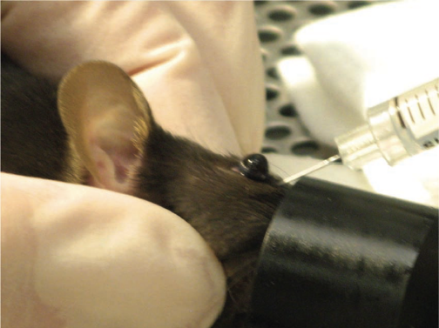

Figure 1:
Placement of needle for RO injection in a mouse

Procedure for Neonatal Mice (≤ 6 d old):

Pups should be separated from their mothers as they may emit stress vocalizations during the procedure. Pups are also susceptible to hypothermia and need to be supplied heat once removed from their home cage. Pups should be contained, on indirect heat, covered with gauze to provide added warmth.

Procedure and Set Up:
- Prepare the syringes first. We suggest using a 31 gauge ½” needle
- Injection volumes cannot exceed 50 μl.
- Anesthetize the mouse as described in the protocol(if necessary)
- Remove the mouse from the holding cage and position the mouse on its side. Gently restrain it with the thumb and forefinger of the non-dominant hand.
- Insert approximately 1/4 of the needle length, bevel down, at a 45° angle in the area that will become the medial canthus (3 o’clock position into the eye socket). The needle will be positioned behind the globe of the eye in the retro-bulbar sinus. A sharp cutting needle is preferred as it results in reduced tissue distortion and damage.
- Inject into the retro-bulbar sinus.
- Remove needle gently to avoid injury to the eye.
- Apply mild pressure to the injection site with a gauze sponge.

References: Yardeni T, Eckhaus M, Morris D, Huizing M, Hoogstraten-Miller S. Retro-orbital injection in mice. Lab Anim (NY) 2011 May; 155-16.-

